

22f-3104

DB Lab 10



March 29, 2024

fast cfd campus

**Task 1:**

**Create a view named "HighSalaries" that contains the names and salaries of employees from the "EMP" table with salaries greater than 2,450.**

**Display all records from the "HighSalaries" view.**

**Code:**

CREATE VIEW HighSalaries AS SELECT ename, sal

FROM EMP WHERE sal > 2450;

SELECT * FROM HighSalaries;

**Screen Shot:**

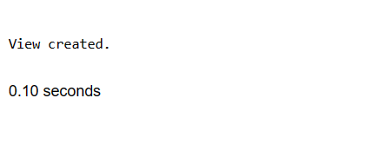

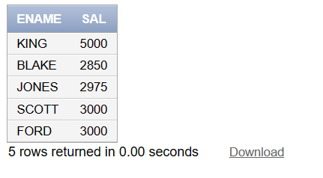

**Task 2:**

**Create a view named "DepartmentLocations" that contains department names and their respective locations from the "DEPT" table.**

**Code:**

CREATE VIEW DepartmentLocations AS

SELECT dname, loc

FROM DEPT;

SELECT * FROM DepartmentLocations;

**Screen Shot:**

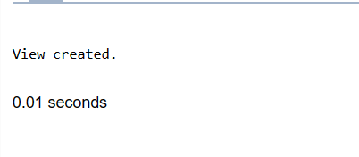

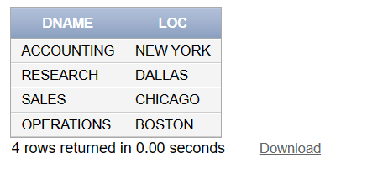

**Task 3:**

**Create a view named "Managers" that contains the names and job titles of employees from the "EMP" table with job titles like "MANAGER."**

**Display all records from the "Managers" view.**

**Code:**

CREATE VIEW Managers AS

SELECT ename, job

FROM EMP

WHERE job LIKE '%MANAGER%';

SELECT * FROM Managers;

**Screen Shot:**

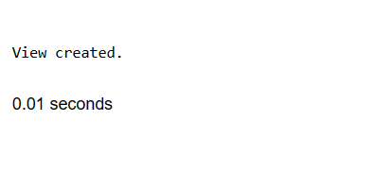

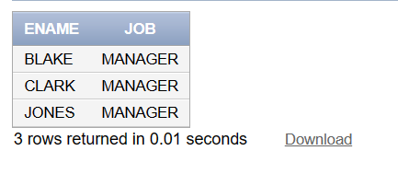

**Task 4:**

**Create a view named "JuniorEmployees" that contains the names and hire dates of employees from the "EMP" table hired in the year 1980.**

**Display all records from the "JuniorEmployees" view.**

**Update “SMITH” employee name in the "EMP" table as "YourName". (Ensure that JuniorEmployees view now contains your name.)**

**Code:**

**Screen Shot:**

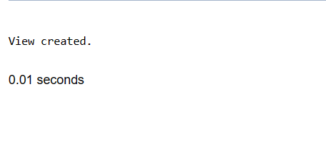

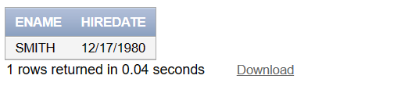

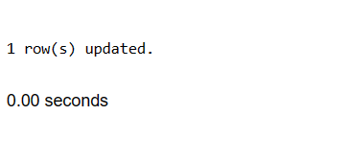

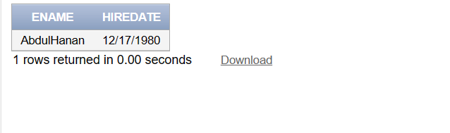

**Task 5:**

**Code:**

==(Drop the "HighSalaries" view)==

DROP VIEW HighSalaries;

==(Drop the "DepartmentLocations" view)==

DROP VIEW DepartmentLocations;

==(Drop the "Managers" view)==

DROP VIEW Managers;

==(Drop the "JuniorEmployees" view)==

DROP VIEW JuniorEmployees;

**Screen Shot:**

**High Salaries View**

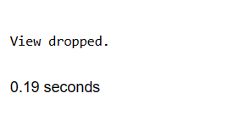

**"DepartmentLocations"**

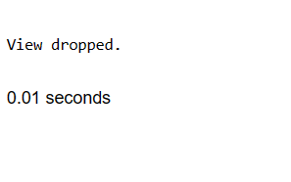

**"Managers"**

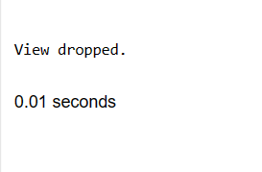

**"JuniorEmployees"**

